# Wild plant produce edibibility prediction

1.Introduction

1.1.Overview:

The rural communities of developing countries depend on wild edible plants to meet their food requirements during periods of food shortage. Wild edible plants are mostly serving as supplementary foods in different parts of the world because they are nutritionally rich and can supplement especially vitamins and micronutrients. The main objective of this project is to build Convolutional neural networks are a deep model to detect and classify the edibility of the wild plant. The model also suggests the effects of non-edible wild plant produce.

1.2.Purpose:

We are creating a web application where the user selects the image which is to be classified. The image is fed into the model that is trained and the predicted class will be displayed on the webpage.

2.LITERATURE SURVEY:

2.1.Existing problem:

Eating even a tiny bite of a toxic plant can cause extreme gastrointestinal problems, or even death. Survival experts devised this test to determine a plant’s edibility. So if you want to know how to tell if a wild plant is edible, you are in right place.

The Universal Edibility Test is a series of steps you take to determine whether a plant is poisonous or safe to eat. The idea of the steps is to gradually expose your body to the plant and see if any reaction occurs.

**2.2. Proposed solution:-**

If you do not know with 100% confidence what you are eating during a survival situation, follow this Edible Plants Test to the letter. The first thing you need to know is that this test will take you a lot of time (17 hours approximately) and effort to do correctly. However, that is better than poisoning yourself to death. With that said, you do not want to wait until your 16th day without food to start this test.

Before we jump on to the test procedure, let us remind you that some plants can be poisonous if you eat them. Whereas some might hurt you if you get them on your skin. For some plants, all parts of the plant are poisonous. For others, only certain parts of the plant are harmful. The danger can range from mild irritation to severe illness or even death (rare). But in a survival situation, if you fall ill, that illness might kill you because of the non-availability of necessary medical care. Therefore, it is very important that you perform an edible plants test on any plant you eat.

3.Theoritical Analysis:

3.1.Technical Architecture:

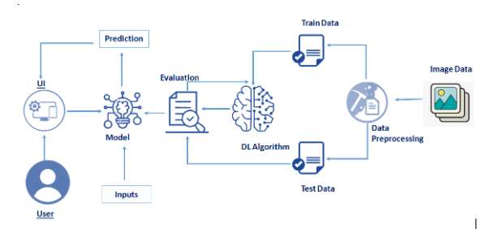

**3.2.Hardware/software designing**

**Software Requirements:**

* OS – Windows XP,7,8,10
* Jupyter Software
* Spyder Software
* Anaconda Command Prompt

**Hardware Components:**

* Processor – i3
* Hard Disk Storage – 10 GB
* RAM – 1GB

**4.EXPERIMENTAL INVESTIGATIONS:-**

Classifing the given images checking the edibility parts of the plant For each and every image we specifie the pridection for the edibility

**5.Results:-**

Image Pre-processing includes the following main tasks

* Import ImageDataGenerator Library.
* Configure ImageDataGenerator Class.
* Applying ImageDataGenerator functionality to the trainset and test set.
* The model is to be tested with different images to know if it is predicting correctly.
* After the model is built, we will be integrating it into a web application so that normal users can also use it. The users need to give the Wild plant images to know the predictions.

**6.ADVANTAGES AND DISADVANTAGES:**

**Advantages:**

1.Shows the edibility parts in the wild plants.

2.Getting new and neutrious plants that are helpful for man kind.

**Disadvantages:**

1.Due to lack of awareness many people are falling ill.

2.some of them are poisonous and may cause to death.

**8.CONCLUSION :-**

* Preprocess the images.
* Applying the CNN algorithm on the dataset.
* You will be able to know how to find the accuracy of the model.
* You will be able to build web applications using the Flask framework.

**Source code:**

#import required libraries

import numpy as np

import os

#import Flask

from flask import Flask , request, render_template

from werkzeug.utils import secure_filename

from gevent.pywsgi import WSGIServer

#import keras

import keras

from tensorflow.keras.models import load_model

from tensorflow.keras.preprocessing import image

import tensorflow as tf

from tensorflow.keras.optimizers import Adam

app = Flask(__name__)

model = load_model("edible-non.h5")

@app.route('/')

def index():

return render_template('index.html')

@app.route('/predict',methods = ['GET','POST'])

def upload():

if request.method == 'POST':

f = request.files['image']

print("current path")

basepath = os.path.dirname(__file__)

print("current path", basepath)

filepath = os.path.join(basepath,'uploads',f.filename)

print("upload folder is ", filepath)

f.save(filepath)

img = image.load_img(filepath,target_size = (128,128))

x = image.img_to_array(img)

x = np.expand_dims(x,axis =0)

a=np.argmax(model.predict(x),axis=1)

print("prediction",a)

index = ['Asparagus_edible','Blue Vervain_edible','Cattail_edible',

'Chicory_edible_non edible','Fireweed_edible_non edible',

'green castor bean_non edible']

text = "prediction : "+ index[a[0]]

return text

if __name__ == '__main__':

app.run(debug = True,port=8000)

**Output:**

